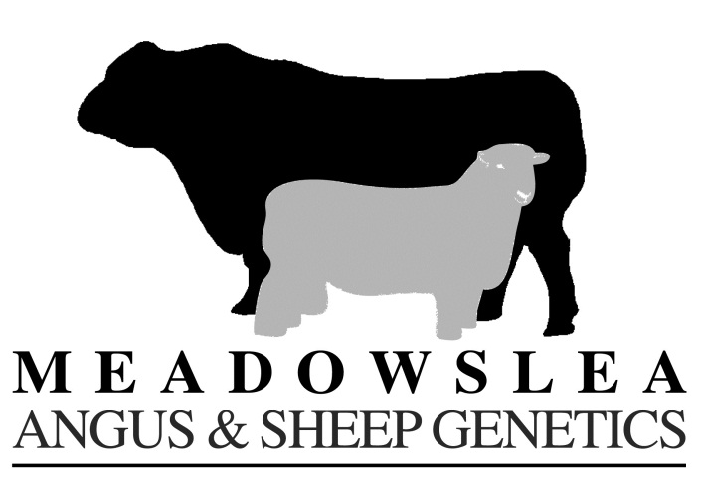

**Autumn Update 2018**

We hope the recent rains start to turn the season around for all our southern clients. At least this will help ensure market prices remain firm for the balance of stock yet to be sold.

Long term, we are certain that demand for breeding stock will be strong, since nationally capital breeding beef and sheep numbers are estimated to be 10 million stock units short.

**Southern Fieldays** – **Meadowslea** will be exhibiting at the **Waimumu Fieldays** on **February 14th – 16th. Our site is 571** (on the aisle right next to the carpark)

We will have a selection of **rams for the Autumn Ram Sale** on display and information on our up-coming Angus Female Sale and Winter Bull Sale.

We look forward to catching up with our many southern clients, having a chat about your breeding programmes, and talking rams and bulls.

We are sharing our tent with **Beltex NZ** so it is a great chance to check out New Zealand’s newest sheep breed while you are there!

**Wanaka Show -** we will again have our tent at the Wanaka Show at the same site as usual – **beside the Rugby club-rooms**, on the ring-side opposite the Farmlands tent.

We always look forward to catching up with many clients at Wanaka, and with it being only a week before our Autumn Ram sale it is a great time to ensure your ram team is all good-to-go before mating.

**PT0**

**Important Dates**

**Autumn Ram Sale** – **Friday March 16th**

We will offer **120 2th rams** across all breeds including a selection for hogget mating:

***- Romney - Romdale - Texel x Rom - Perendale x Texel x Romney***

***- Kelso x Romney - Kelso Maternal - Kelso Terminal (black-face)***

***Hogget Mating*** – there is strong interest in mating hoggets this year and we will have ram hoggets available for lease – give us a call to discuss the options.

**2nd Annual Angus Performance In-Calf Female Sale**

**Wednesday May 2nd**

We will offer approximately **80 Stud Females** – R2, R3, R4, and AD Capital Stock Cows. Also approximately **60 in-calf R2yr** **Commercial Meadowslea**-**bred heifers** - (ex Grays Hills Station, Braemar Station, Guide Hill Station and Manahune Station)

All stud females are mated to the top sires at Meadowslea with the R2yr heifers mated to our very best calving-ease yearling bulls – many of which will feature at the very top of our winter bull sale catalogue.

**Winter Bull Sale Friday June 22nd**

Wewill have a great line-up of approximately **70 hill-country bulls** on offer, with exceptional depth, thickness, and the easy-doing attributes Meadowslea bulls are renowned for.

We wish you all the best for the remainder of the season, and hope to catch up with you over the autumn.

Kind Regards,

David Giddings

*and all the team at Meadowslea 027 2299760 or 03 6858027*

[giddingsfamily@xtra.co.nz](mailto:giddingsfamily@xtra.co.nz) [www.meadowslea.co.nz](http://www.meadowslea.co.nz) follow us on facebook